ACKNOWLEDGEMENT
I would like to express my sincere gratitude to King Fahd University of Petroleum and Minerals (KFUPM), Dhahran, Saudi Arabia, for providing me with the opportunity to undertake my summer internship at the Interdisciplinary Research Center for Sustainable Energy Systems (IRC-SES). This internship provided an excellent platform to gain practical exposure to renewable energy research, photovoltaic system modeling, and power electronics through advanced simulation and analysis.
I would like to express my heartfelt appreciation to Dr. Ali Ahmed Salem, my internship supervisor, for his invaluable guidance, continuous encouragement, technical expertise, and constructive suggestions throughout the internship. His mentorship played a significant role in the successful completion of this project.
I am also sincerely thankful to Dr. Mohammed Maslehuddin, Dr. Waleed Mohammed Hamanah, and all researchers, engineers, and staff members of the Interdisciplinary Research Center for Sustainable Energy Systems (IRC-SES) for their constant support, insightful discussions, and for providing a collaborative research environment that greatly enhanced my learning experience.
Finally, I wish to express my deepest gratitude to my parents, family members, and friends for their unwavering support, patience, encouragement, and belief in me throughout my academic journey. Their constant motivation has been a source of strength during the completion of this internship.
This internship has been an invaluable learning experience that has strengthened my technical knowledge, research skills, and practical understanding of photovoltaic systems, partial shading analysis, and Maximum Power Point Tracking (MPPT). I am grateful to everyone who contributed, directly or indirectly, to the successful completion of this work.

ABSTRACT

This report presents the work carried out during a summer internship at the Interdisciplinary Research Center for Sustainable Energy Systems (IRC-SES), King Fahd University of Petroleum and Minerals (KFUPM), Dhahran, Saudi Arabia. The internship focused on the modeling, simulation, and performance analysis of photovoltaic (PV) systems using MATLAB/Simulink, with particular emphasis on the effects of partial shading and Maximum Power Point Tracking (MPPT). A 4 × 4 Total Cross-Tied (TCT) photovoltaic array was developed to investigate the influence of different partial shading scenarios on the electrical characteristics and power output of the system. The conventional Perturb and Observe (P&O) MPPT algorithm was also implemented and evaluated under dynamic irradiance and temperature conditions to assess its tracking performance. The study provided practical experience in PV system modeling, power electronics, simulation techniques, and renewable energy research. Overall, the internship strengthened both technical and analytical skills while providing valuable insight into the design and optimization of photovoltaic systems for improved energy harvesting under real-world operating conditions.

Table of Contents
1. Introduction and Project Framework
1.1 Overview of Renewable Energy Systems.......................................1
1.1.1 Regional Shifts and Strategic Vision.................................1
1.1.2 The Engineering Challenge............................................2
1.2 Host Institution Profile...................................................2
1.2.1 Institutional Overview: KFUPM........................................2
1.2.2 Interdisciplinary Research Center for Sustainable Energy Systems.....2
1.2.3 Clean Energy Research Focus..........................................2
1.3 Problem Statement.........................................................2
1.3.1 Part A: Structural Mismatch Losses in TCT Arrays.....................3
1.3.2 Part B: Controller Tracking Lag under Dynamic Cloud Conditions.......3
1.4 Project Objectives........................................................3
2. Step-by-Step Engineering Progress
2.1 Planning and Software Verification........................................4
2.2 Mathematical Modeling and Software Solutions...............................4
2.2.1 Solar Cell PV........................................................4
2.3 Design Review and Software Setup Optimization..............................5
2.4 Shading Simulations and Data Plotting......................................6
2.5 Scaling Up to a 4×4 TCT Array..............................................6
3. Theoretical Aspects and Simulation Analysis
3.1 PV Array Interconnection Topologies and the Physics of Partial Shading.....7
3.1.1 Structural Comparison: Series-Parallel (SP) vs. Total Cross-Tied (TCT)...7
3.1.2 The Physics of Partial Shading Conditions (PSC)......................7
3.1.3 Deformation of P–V and I–V Characteristics...........................8
4. Maximum Power Point Tracking (MPPT) Analysis Under Dynamic Irradiance
4.1 MPPT Analysis Under Dynamic Irradiance.....................................10
4.1.1 Impact of Environmental Variations on PV Characteristics............10
4.1.2 Perturb and Observe (P&O) MPPT Algorithm............................11
4.2 Case Study Application and Performance Analysis...........................12
4.3 Results and Discussion...................................................13
5. Associated Research and Publications….14
6. Conclusion
7. references

SUMMER INTERNSHIP REPORT
Host Institution: King Fahd University of Petroleum and Minerals (KFUPM), Dhahran, Saudi Arabia
Department: Interdisciplinary Research Center for Sustainable Energy System

1. Introduction and Project Framework

1.1 Overview of Renewable Energy Systems
In recent decades, the global energy landscape has been undergoing a paradigm shift, driven by the dual pressures of rapidly depleting fossil fuel reserves and the accelerating crisis of global climate change. Traditional power generation relies heavily on conventional hydrocarbons, which contribute significantly to greenhouse gas emissions and environmental degradation. To mitigate these effects and achieve global sustainability goals, such as those outlined in the Paris Agreement, there is an urgent international imperative to transition toward clean, sustainable, and renewable energy resources.
Among the various renewable alternatives—including wind, hydro, biomass, and geothermal energy—solar photovoltaic (PV) technology has emerged as one of the most prominent and fast-growing sectors. Solar energy offers a virtually inexhaustible, decentralized, and environmentally benign source of power. Advancements in semiconductor manufacturing, coupled with a drastic reduction in the levelized cost of electricity (LCOE) for solar installations, have transitioned solar PV from a niche alternative to a mainstream pillar of the modern grid [1].

1.1.1 Regional Shifts and Strategic Vision
Regionally, this shift is particularly pronounced in solar-abundant areas such as the Middle East. Countries within the Gulf Cooperation Council (GCC), historically central to the global hydrocarbon economy, are now aggressively diversifying their energy portfolios. A premier example of this transition is Saudi Arabia’s Vision 2030, which targets a massive integration of renewable energy into the national grid, aiming for renewables to comprise approximately 50% of the kingdom's energy mix by 2030. Driven by the National Renewable Energy Program (NREP), the region is leveraging its exceptional geographic solar irradiance to deploy mega-scale projects, such as the Sudair and Sakaka solar plants [2].

1.1.2 The Engineering Challenge
However, scaling solar PV technology from localized installations to grid-dominant power sources introduces complex engineering challenges. Unlike conventional generation, solar PV output is highly intermittent and strictly dependent on meteorological conditions. On a localized level, environmental factors such as dust accumulation, ambient temperature rises, and transient cloud cover lead to non-uniform irradiance, a phenomenon known as Partial Shading Conditions (PSC). When an array is partially shaded, its overall power output does not just drop proportionally; it experiences severe internal mismatches, leading to hot-spot formation and significantly reduced efficiency. Therefore, maximizing the power extraction efficiency of solar infrastructure under real-world dynamic environments remains a critical frontier in power electronics and renewable energy research [3].

1.2 Host Institution Profile

1.2.1 Institutional Overview: KFUPM
King Fahd University of Petroleum and Minerals (KFUPM) in Dhahran, Saudi Arabia, is a globally top-ranked institution renowned for engineering excellence and technological innovation. While historically central to the traditional energy sector, KFUPM has rapidly transitioned to lead advanced research in clean energy, sustainability, and smart grid architectures [4].

1.2.2 Interdisciplinary Research Center for Sustainable Energy Systems
The technical work for this internship was completed in the Interdisciplinary Research Center for Sustainable Energy Systems (IRC-SES) at KFUPM. The Center specializes in cutting-edge power electronics, power systems engineering, and renewable energy integration. It provides students and researchers with industry-grade computational infrastructure, utilizing advanced software tools like MATLAB/Simulink to solve complex engineering challenges [4] [5].

1.2.3 Clean Energy Research Focus
The internship project directly aligned with KFUPM’s active research in renewable systems, specifically focusing on:
- Desert-Environment Solar Modeling: Mitigating the effects of high ambient temperatures and localized atmospheric dust on solar PV arrays.
- Intelligent Power Control: Developing meta-heuristic optimization algorithms and advanced control loops to maximize energy extraction efficiency during dynamic, real-world environmental shifts [5].

1.3 Problem Statement

1.3.1 Part A: Structural Mismatch Losses in TCT Arrays
When a solar array faces Partial Shading Conditions (PSC) from dust, debris, or static shadows, the shaded modules experience a sharp drop in current generation. In standard setups, this forces shaded cells to act as consumers of energy rather than producers, leading to localized power dissipation, dangerous 'hot-spot' heating, and massive system-wide energy losses. While implementing a 4x4 Total Cross-Tied (TCT) topology mitigates this by adding cross-ties that allow current to bypass shaded areas, it alters the electrical characteristics of the system. This structural interconnection deforms the overall system output, turning a clean, single-peak graph into a complex Power-Voltage (P-V) and Current-Voltage (I-V) curve landscape characterized by multiple local peaks. This structural phenomenon must be modeled and mapped to understand exactly how different shading matrices deform the array's power profile.

1.3.2 Part B: Controller Tracking Lag under Dynamic Cloud Conditions
Shifting from a large network structure to a single panel control level introduces a dynamic, time-varying challenge. Real-world atmospheric anomalies, such as fast-moving clouds, subject a solar panel to highly transient shifts in both irradiance and temperature. To capture maximum energy, systems rely on the conventional Perturb and Observe (P&O) Maximum Power Point Tracking (MPPT) algorithm, which operates on a fixed-step, trial-and-error methodology. While P&O is highly effective and stable under steady, uniform sunlight, it is highly vulnerable to rapid weather changes. Under fast dynamic cloud transitions, the algorithm suffers from severe tracking lag—frequently failing to keep up with the rapidly shifting peak or exhibiting heavy power oscillations around it. There is a critical need to evaluate the exact performance boundaries, tracking speed, and power losses of the P&O algorithm when pushed to its limits by highly volatile environmental profiles.

1.4 Project Objectives
To address the challenges of structural power loss and dynamic tracking inefficiencies, this project was executed in two independent, highly focused phases:
Phase 1: Structural and Characteristic Analysis of a 4x4 TCT Array
- Model the Topology: Design and construct a complete 4x4 Total Cross-Tied (TCT) PV array architecture within the MATLAB/Simulink environment.
- Simulate Shading Profiles: Develop and apply multiple static partial shading matrices to the 4x4 network, simulating real-world obstructions like dust accumulation or localized shadows.
- Map Curve Deformations: Extract and analyze the resulting Current-Voltage (I-V) and Power-Voltage (P-V) characteristic curves, mapping exactly how row-level cross-ties cause the formation of multiple local peaks and a single Global Maximum Power Point (GMPP).
Phase 2: Dynamic MPPT Evaluation and Application of a Single PV Panel
- Model Dynamic Environmental Inputs: Configure a standalone single PV panel simulation featuring time-varying, transient signal blocks for both Irradiance (G) and Temperature (T).
- Simulate Dynamic Cloud Cover: Program rapid environmental profiles that mimic fast-moving clouds (sudden step-changes and steep ramps in weather conditions).
- Evaluate P&O Performance Limits: Implement the conventional Perturb and Observe (P&O) MPPT algorithm and quantitatively evaluate its tracking speed, response lag, and steady-state power oscillations when subjected to high-volatility atmospheric conditions.
- Analyze Real-World Control Applications: Apply these tracking limits to small-scale solar infrastructure, evaluating how P&O tracking lag directly impacts energy collection efficiency in commercial micro-inverters, mobile solar-powered systems, and high-volatility desert environments.

2. Step-by-Step Engineering Progress

2.1 Planning and Software Verification
The project began with a plan to model a standard solar PV panel in MATLAB/Simulink. The goal was to observe how the output power changes with different levels of sunlight. Initially, the standard PV Array block could not be used due to version compatibility issues in the software setup, requiring an alternative design approach.

2.2 Mathematical Modeling and Software Solutions
To overcome the software block limitations, a custom PV cell was built from scratch using mathematical formulas and data from a manufacturer's datasheet. However, this custom mathematical model ran into simulation errors and could not generate the proper performance curves. To fix this, the design strategy shifted to physical modeling using the standard Simscape Solar Cell block. Parameterizing this block directly from the datasheet solved the simulation errors and successfully produced accurate I-V and P-V curves.
Governing Electro-Thermal Equation:
$$I = I_{pv}- I_{0}\left[exp⁡(\frac{V + IR_{s}}{aV_{t}})- 1\right]-\frac{V + IR_{s}}{R_{p}}$$

2.2.1 Solar Cell PV
- Solar Cell Block: Represents the physical PV cell under test. It has an irradiance input port (Ir) and a thermal port (H).
- Irradiance Source (G): A constant block set to 1000W/m^2, providing standard test condition (STC) illumination to the cell.
- Variable Resistor (R): Acts as a dynamic electrical load. It is driven by a Ramp Block to automatically sweep the resistance, allowing the model to capture the cell's behavior from short-circuit to open-circuit conditions.
- Measurement Sensors: Ammeter (A) connected in series to measure output current (I), and Voltmeter (V) connected in parallel to measure output voltage (V).
- X-Y Plotters / Scopes: I-V Graph plots Current vs. Voltage to show the standard diode-like solar characteristic curve; P-V Graph plots Power vs. Voltage to identify the Maximum Power Point (MPP).
- Simulation Essentials: Features a Solver Configuration block (f(x)=0) and an Electrical Reference (Ground), both required to solve Simscape physical network equations.
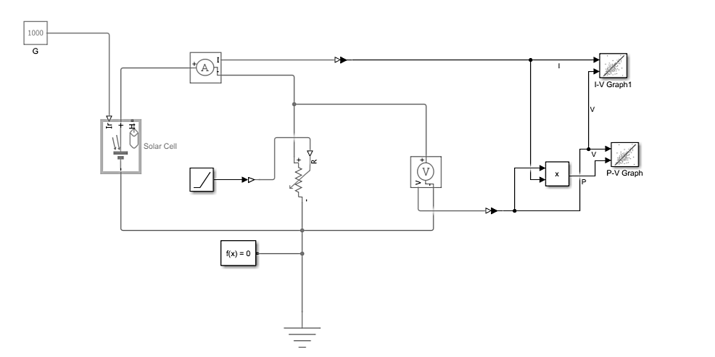
The developed circuit is shown in Figure 1.
Figure 1. The developed circuit.

2.3 Design Review and Software Setup Optimization
The initial simulation results were compiled into a presentation and reviewed with the supervising professor. The modeling approach was approved, and a new task was assigned: simulate partial shading conditions on the solar panels. To support this advanced simulation, the correct MATLAB version was installed on the system. This successfully restored full access to the specialized Simscape Power Systems library, including the standard PV Array and powergui blocks. The Matlab/Simulink model for this is shown in Figure 2.
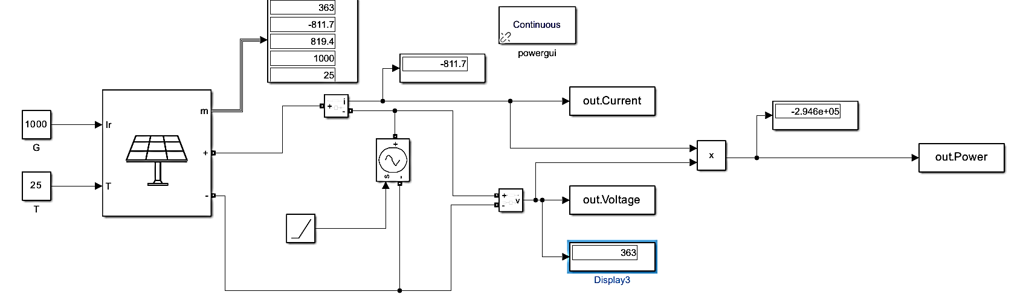

Figure 2. MATLAB/Simulink Model of the PV System

2.4 Shading Simulations and Data Plotting
A smaller solar string using 3 series-connected PV panels as shown in Figure 3 was built to test partial shading. Different sunlight levels were applied to different panels to simulate cloud cover or shadows.
- Bypass Diodes: Diodes were connected across each panel to protect the cells from overheating and to allow current to flow around the shaded areas.
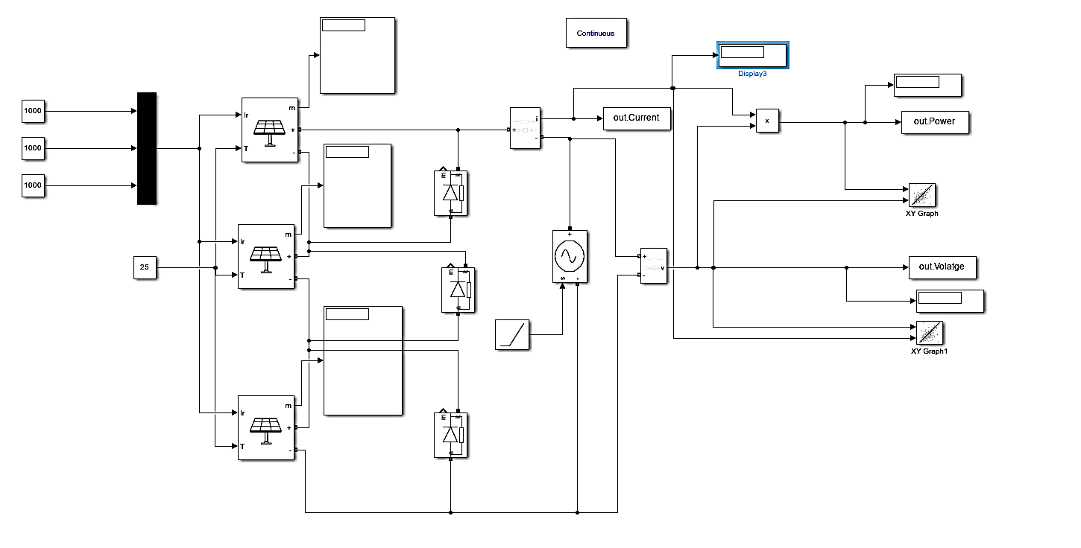
- Voltage Sweeping: A Controlled Voltage Source was used to sweep the voltage from zero up to the open-circuit voltage (Voc). This allowed data to be sent directly to the MATLAB Command Window to plot curves showing multiple power peaks caused by the shading.
Figure 3. Series connected string of three panels

2.5 Scaling up to a 4x4 TCT Array
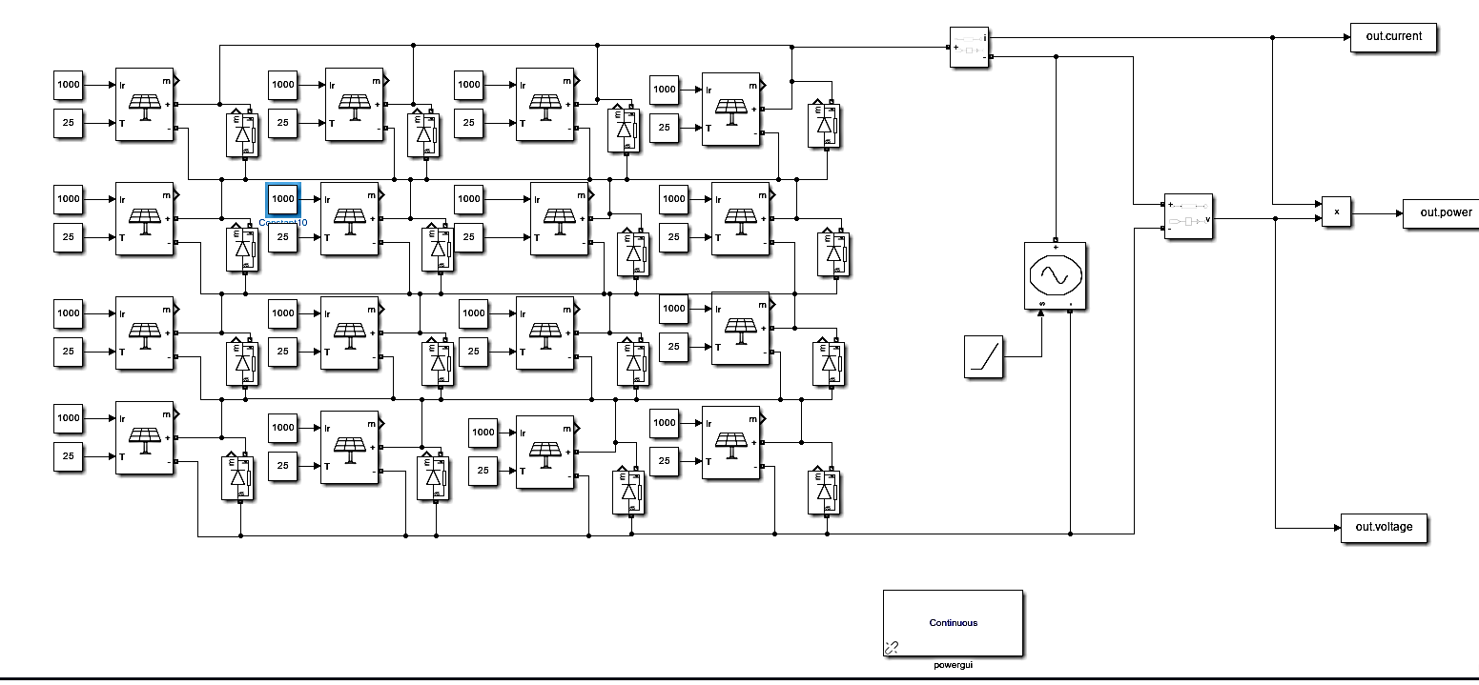
The multi-panel shading design was scaled up into a larger 4x4 PV Matrix Array as shown in Figure 4 consisting of 16 individual modules. The modules were wired using a Total Cross-Tied (TCT) layout, where panels are connected in parallel rows and then connected in series columns. A signal Multiplexer (Mux) layout was integrated into the model to control and monitor the inputs for each row cleanly, ensuring the full simulation runs smoothly.

FIGURE 4. 4x4 TCT PV array architecture

3. Theoretical Aspects and Simulation Analysis

3.1 PV Array Interconnection Topologies and the Physics of Partial Shading

3.1.1 Structural Comparison: Series-Parallel (SP) vs. Total Cross-Tied (TCT)
The electrical performance of a solar photovoltaic (PV) system operating under environmental stress is heavily dictated by how individual modules are structurally interconnected.
- Series-Parallel (SP) Configuration: In a conventional SP architecture, modules are connected end-to-end in series strings to achieve the desired system voltage, and these strings are then connected in parallel to meet current requirements. The critical flaw of this setup occurs during localized obstruction. Because current in a series string is strictly limited by its weakest link, a drop in irradiance on just one module forces that entire string's current down to the shaded level, severely isolating and penalizing the string's output.
- Total Cross-Tied (TCT) Configuration: The TCT topology eliminates this vulnerability by adding hardwired electrical cross-ties across the junctions of each parallel row, forming a tightly bound matrix. In a 4x4 TCT array, instead of isolated vertical strings, the rows are tied together at every node. When partial shading occurs, this grid-like loop structure creates alternative, low-resistance bypass paths. The current from unshaded modules can redistribute across the cross-ties, flowing around the shaded module rather than being choked by it.

3.1.2 The Physics of Partial Shading Conditions (PSC)
To understand why the TCT configuration alters system characteristics, it is necessary to examine the semiconductor physics of a PV cell under Partial Shading Conditions (PSC). A solar cell acts as a current source when exposed to photons. When a shadow from a moving cloud or dust cuts off this light, photon absorption drops, and the cell's internal current-generation capacity decreases. However, the unshaded cells in the network continue trying to push their high, full-sun current through the circuit. To maintain current continuity, the shaded cell is forced into a reverse-bias voltage state. Instead of producing power, the shaded cell begins to consume power, dissipating the energy generated by surrounding cells as pure heat. This phenomenon leads to hot-spot formation, which can cause localized thermal runaway, melt encapsulation layers, and permanently destroy the PV module. To prevent this catastrophic failure, bypass diodes are wired in parallel with the modules. When a module drops into reverse bias, the bypass diode turns on (conducts), allowing the excess current to safely skip past that module.

3.1.3 Deformation of P-V and I-V Characteristics (Multi-Peak Phenomena)
While bypass diodes protect the physical array from burning out, their conduction completely deforms the system's output curves. Under uniform irradiance, every module operates at identical parameters, resulting in a smooth, ideal Current-Voltage (I-V) curve and a clean, single-peak Power-Voltage (P-V) curve. When partial shading forces different rows and modules into varying irradiance states, different bypass diodes activate at different voltage thresholds. Every time a bypass diode turns on to short-circuit a shaded section, it creates a sharp step-change in the overall I-V curve. When mapped to the P-V power curve, these steps deform the graph into a multi-peak landscape. Instead of a single maximum point, the curve now exhibits multiple Local Maxima (sub-optimal power peaks) and only one true Global Maximum Power Point (GMPP).The curves for different scenarios are shown in Figure 5.

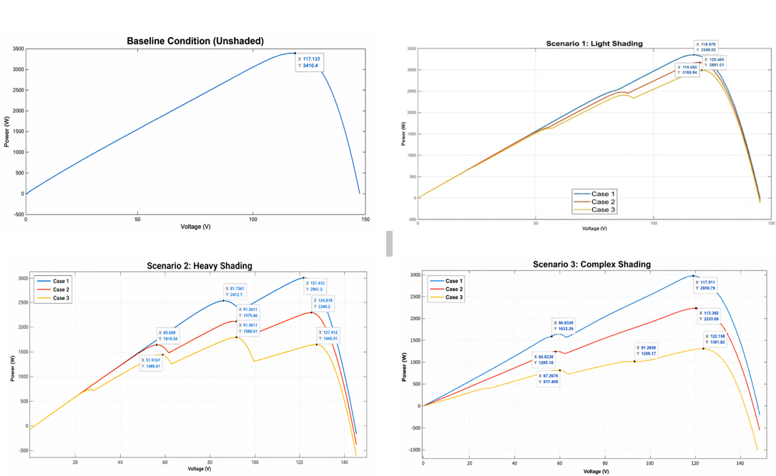
Figure 5. P-V curves for different scenarios and cases
The P–V characteristics for SP1 model a low-density, transparent shadow moving over the array corner. During the Initial Corner Shadow step ($G_{11}=800 {\text{W/m}}^{2}$), the array maintains near-ideal uniform performance, yielding a Global Maximum Power Point (GMPP) of $3348.02\text{ W}$at $116.98\text{ V}$. As the shadow expands to three modules during the Light Corner Shading step, a minor inflection point develops near $90\text{ V}$, shifting the GMPP to $3168.94\text{ W}$at $119.59\text{ V}$. At full expansion during the Expanded Light Corner Shading step, a mild multi-peak profile emerges with a GMPP of $2991.01\text{ W}$at $120.46\text{ V}$. This progression demonstrates that low-opacity shading preserves a high Fill Factor due to minimal cross-string current bottlenecks.Scenario 2 simulates a dense obstruction forcing extensive bypass diode conduction. In the Initial Localized Blockage step ($G_{11}=200 {\text{W/m}}^{2}$), a distinct knee inflection point appears, but the cross-tied connections successfully bypass the fault to maintain a GMPP of $2976.61\text{ W}$at $121.41\text{ V}$. When the obstruction expands into a $2×2$cluster during the Expanding Obstruction step, severe mismatches produce a prominent multi-peak curve, locating the true GMPP at $2294.20\text{ W}$($124.90\text{ V}$). Under the Full Heavy Corner Obstruction step, sharp current limits choke the rows, collapsing the GMPP to $1658.61\text{ W}$at $127.51\text{ V}$and generating distinct step-like staircase drops across the voltage axis. This profile examines distributed diagonal shading. As shading intensifies, the P–V curve becomes increasingly distorted, reducing the GMPP from 2919.78 W to 1301.62 W while creating multiple local maxima that significantly challenge global MPPT algorithms.

TABLE 1. Losses and Performance evaluation
Shading Scenario | Progression Step Name | Vmpp​ (V) | PGMPP​ (W) | Absolute Power Loss (W) | Relative Power Loss (%)
Ideal Baseline (STC) | — | — | 3410.40 | 0.00 | 0.00%
Scenario 1: Light Shading (SP1) | Case1: Initial Corner Shadow | 116.98 | 3348.02 | 62.38 | 1.83%
 | Case2: Light Corner Shading | 119.59 | 3168.94 | 241.46 | 7.08%
 | Case 3: Expanded Light Corner Shading | 120.46 | 2991.01 | 419.39 | 12.30%
Scenario 2: Heavy Shading (SP2) | Case 1: Initial Localized Blockage | 121.41 | 2976.61 | 433.79 | 12.72%
 | Case 2: Expanding Obstruction | 124.90 | 2294.20 | 1116.20 | 32.73%
 | Case 3: Full Heavy Corner Obstruction | 127.51 | 1658.61 | 1751.79 | 51.37%
Scenario 3: Complex Shading (SP3) | Case1: Incipient Diagonal Gradient | 117.51 | 2919.78 | 490.62 | 14.39%
 | Case 2: Deepening Diagonal Shadow | 118.38 | 2233.99 | 1176.41 | 34.49%
 | Case 3: Chaotic Distributed Shading | 122.16 | 1301.62 | 2108.78 | 61.83%

4. Maximum Power Point Tracking (MPPT) Analysis under Dynamic Irradiance

4.1 Maximum Power Point Tracking (MPPT) Analysis under Dynamic Irradiance

4.1.1 Impact of Environmental Variations on PV Characteristics
A Photovoltaic (PV) cell is a highly non-linear device whose electrical output characteristics are governed directly by environmental factors, primarily solar irradiance (G) and ambient temperature (T). During real-world operation, atmospheric disturbances such as cloud movement cause rapid variations in solar irradiance. When irradiance drops due to a passing cloud, the photogenerated current within the PV cell decreases proportionally, leading to a drastic reduction in the maximum available power output. Conversely, as the cloud clears, the irradiance levels spike, shifting the operating curves upward. To ensure that the PV system continuously extracts the absolute maximum available power under these highly dynamic atmospheric conditions, an active tracking mechanism must be integrated into the power electronics interface.

4.1.2 Perturb and Observe (P&O) MPPT Algorithm
The Perturb and Observe (P&O) algorithm is a widely utilized, hill-climbing optimization technique executed within the digital controller to track the Maximum Power Point (MPP). The operational logic relies on a periodic perturbation of the PV system operating voltage (V_pv) by modifying the duty cycle (D) of the interfacing DC-DC Boost converter.
- Sensing: The instantaneous voltage (V_pv(k)) and current (I_pv(k)) are sampled from the array terminals.
- Power Computation: P_pv(k) = V_pv(k) x I_pv(k).
- Slope Evaluation: The algorithm calculates Delta P = P_pv(k) - P_pv(k-1) and Delta V= V_pv(k) - V_pv(k- 1). If Delta P > 0, perturbation continues in the same direction. If Delta P < 0, direction is reversed.
The variation in irradiance can lead for the tracker to move dynamically from the fixed point (see figure 6 and figure 7)

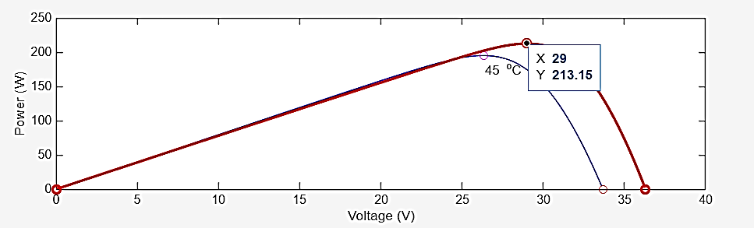
25°C with 1000 w/m^2 Irradiance

Figure 6. Power–Voltage (P–V) Characteristic of the Photovoltaic Module under Unshaded (Baseline) Conditions at 25°C and 45°C.

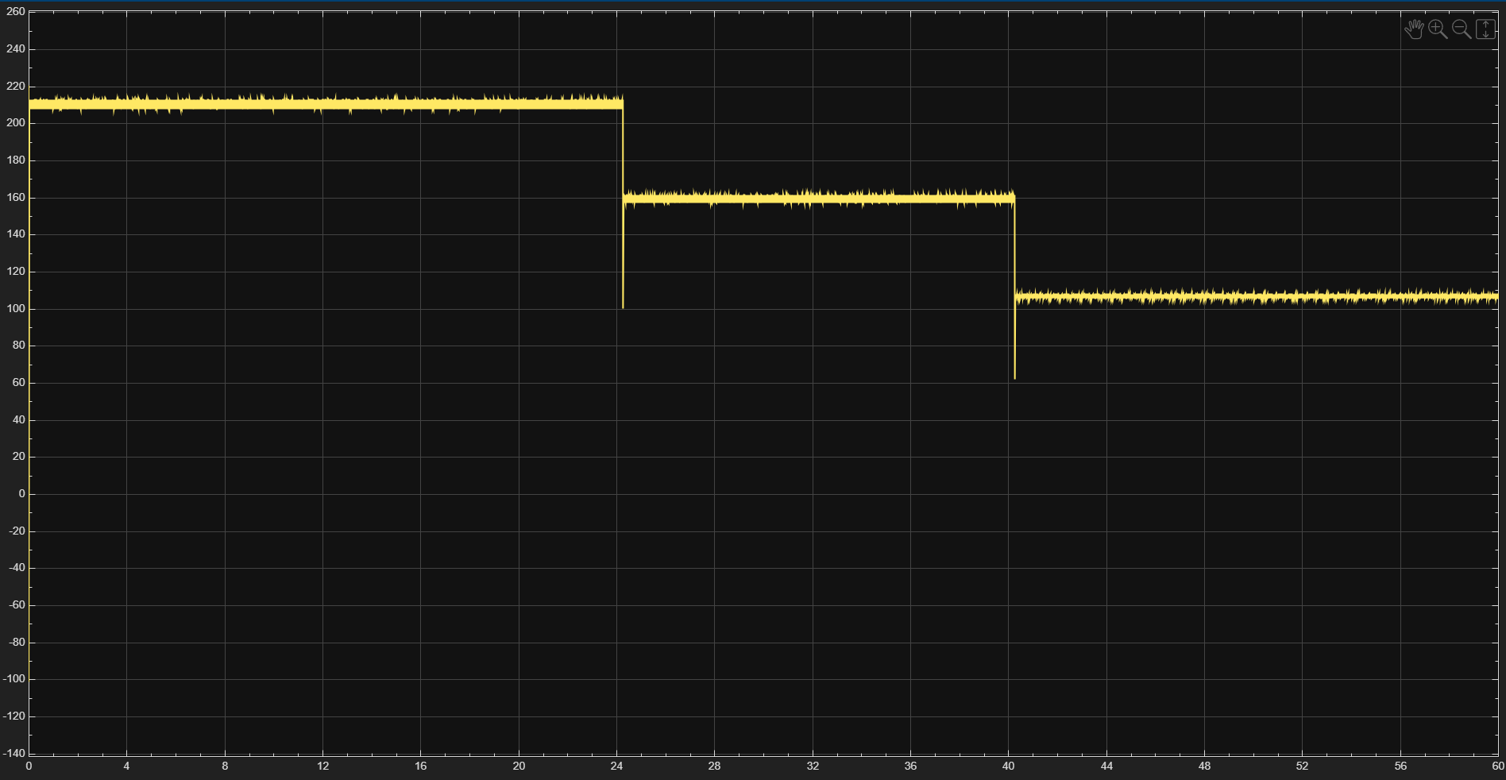

Figure 7. MPPT simulation by varying irradiance at different intervals

4.2 Case Study Application and Performance Analysis
To test the system configuration under severities matching localized GCC environments, real empirical data from Dammam, Saudi Arabia (26.42 N, 50.08 E) was evaluated for the five Tuesdays of June 2021. The 13-hour daily profile (see Table 2) is compressed systematically into a 130-second timeline. The Internal module configuration is given below :-
- Number of Cells per Module: 60
- Number of Series Modules (Ns): 1
- Number of Parallel Strings (Npp): 4
- Nominal Module Power (STC): 213.15 W
- Total Array Peak Capacity (STC): 852.60 W

TABLE 2. Solar Data for five Tuesdays of June 2021
Sim Time (s) | Real-World Time | June 1 (G|T) | June 8 (G|T) | June 15 (G|T) | June 22 (G|T) | June 29 (G|T)
0 | 5:30 AM | 36 | 31.2 | 37 | 31.5 | 12 | 30.9 | 32 | 30.5 | 27 | 30.8
10 | 6:30 AM | 218 | 32.8 | 222 | 32.9 | 182 | 32.4 | 212 | 32.0 | 199 | 32.2
20 | 7:30 AM | 434 | 35.0 | 441 | 34.8 | 392 | 34.2 | 430 | 34.2 | 409 | 34.7
30 | 8:30 AM | 644 | 37.3 | 648 | 36.5 | 596 | 36.3 | 639 | 36.6 | 610 | 37.1
40 | 9:30 AM | 818 | 38.8 | 824 | 37.7 | 770 | 38.1 | 818 | 38.1 | 781 | 39.8
50 | 10:30 AM | 941 | 39.6 | 950 | 38.5 | 898 | 39.7 | 944 | 38.8 | 905 | 41.6
60 | 11:30 AM | 1003 | 40.1 | 1011 | 39.0 | 966 | 40.7 | 1005 | 39.1 | 968 | 41.8
70 | 12:30 PM | 1001 | 40.3 | 1019 | 39.3 | 1016 | 41.3 | 1018 | 39.1 | 965 | 41.7
80 | 1:30 PM | 924 | 40.3 | 942 | 39.3 | 938 | 41.3 | 944 | 39.0 | 897 | 41.4
90 | 2:30 PM | 789 | 40.2 | 801 | 39.2 | 798 | 40.8 | 809 | 38.6 | 770 | 41.0
100 | 3:30 PM | 608 | 39.7 | 612 | 38.8 | 614 | 39.8 | 628 | 37.9 | 596 | 40.5
110 | 4:30 PM | 393 | 38.7 | 396 | 37.9 | 400 | 38.2 | 414 | 36.7 | 394 | 39.6
120 | 5:30 PM | 176 | 36.8 | 178 | 36.3 | 185 | 35.7 | 195 | 35.0 | 187 | 37.9
130 | 6:30 PM | 12 | 34.5 | 11 | 34.0 | 16 | 33.2 | 22 | 32.9 | 21 | 35.7

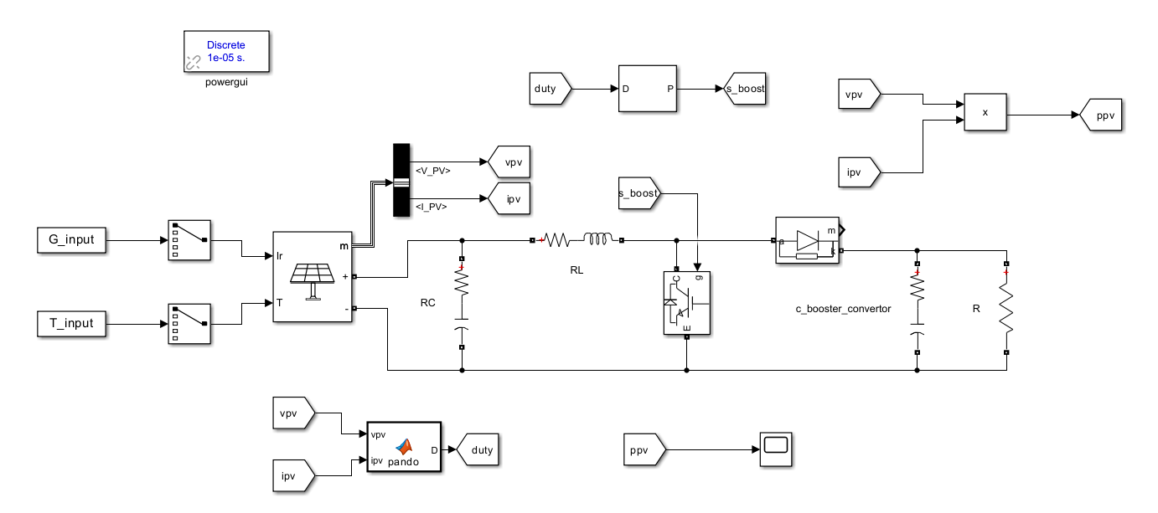
4.3 Results and Discussion

Figure 8. MATLAB/Simulink Model of the Proposed PV System with Boost Converter and Perturb & Observe (P&O) MPPT Controller

A Simulink Model was made to evaluate and track max. power point which can be seen in Figure 8.
i. Optimal Daily Generation Window: The simulation curves show that the absolute best time for solar PV power generation across all days occurs between 11:30 AM and 01:30 PM (simulation runtime t = 60 s to 80 s). During this period, the solar zenith angle is at its minimum, driving horizontal irradiance to its daily peak past 1000 W/m^2.
ii. Comparative Performance and Thermal Degradation Analysis: When simulated, the array outputs a maximum tracking peak of 800.0 W at an irradiance of 1003 W/m^2 and ambient temperature of 40.1C (see Figure 9). Under real operating conditions in Dammam, internal cell temperatures rise, decreasing voltage efficiency by roughly 11.6 percent. However, the system maintains minimal losses, proving the P&O MPPT control loop operates efficiently.
iii. Identification of the Optimum Tuesday: A comparison of the datasets identifies June 22 as the optimum Tuesday for total energy yield. It balances high peak irradiance (1018 W/m^2) with a lower localized thermal profile (39.1C), maintaining voltage stability.
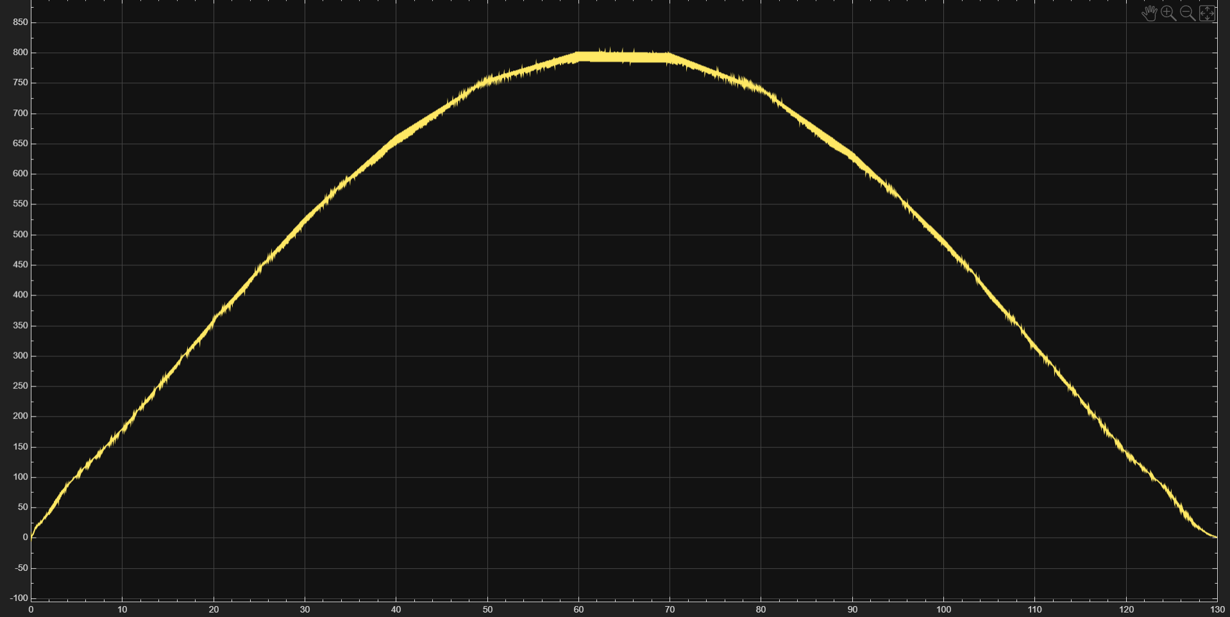

Figure 9. Photovoltaic Output Power Profile Over Time

5. Associated Research and Publications
In addition to the practical engineering implementations and simulations outlined within this report, substantial effort was dedicated to academic formalization. Based directly on the results obtained during this internship, a complete conference paper has been written:
Title: PERFORMANCE EVALUATION OF A 4X4 TOTAL CROSS-TIED PHOTOVOLTAIC ARRAY UNDER DIFFERENT PARTIAL SHADING CONFIGURATIONS
Status: Completed and structured for submission to an upcoming IEEE/international clean energy conference.

6. CONCLUSION
In summary, this internship project successfully evaluated the performance boundaries of solar photovoltaic architectures under environmental stress through a two-phased simulation approach. Phase 1 demonstrated that while a 4x4 Total Cross-Tied (TCT) topology introduces complex multi-peak power deformations due to bypass diode conduction, it effectively mitigates catastrophic mismatch and hot-spot losses by providing alternative current routing paths around localized obstructions. Phase 2 exposed the localized challenges of dynamic tracking lag inherent to the conventional Perturb and Observe (P&O) MPPT algorithm when subjected to rapid environmental transitions and high thermal profiles, such as those modeled using empirical data from Dammam, Saudi Arabia.
Ultimately, analyzing these two distinct operational challenges highlights the critical need for standalone optimization at both the system network level and the individual controller level to maximize the efficiency of solar infrastructure deployed in high-volatility desert environments.

7. References
[1] International Energy Agency, World Energy Outlook 2024. Paris, France: IEA, 2024.
[2] International Renewable Energy Agency, Renewable Power Generation Costs in 2023. Abu Dhabi, UAE: IRENA, 2024.
[3] Saudi Vision 2030, Vision 2030. Riyadh, Saudi Arabia, 2016.
[4] King Fahd University of Petroleum and Minerals, King Fahd University of Petroleum and Minerals, Dhahran, Saudi Arabia.
[5] Interdisciplinary Research Center for Sustainable Energy Systems, Interdisciplinary Research Center for Sustainable Energy Systems (IRC-SES), King Fahd University of Petroleum and Minerals, Dhahran, Saudi Arabia.
- THANK YOU

